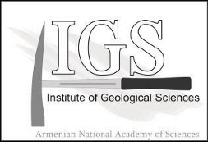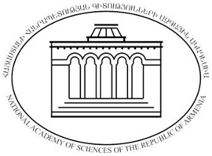

NATIONAL ACADEMY OF SCIENCES OF REPUBLIC OF ARMENIA
INSTITUTE OF GEOLOGICAL SCIENCES

IGCP 630 FIELD WORKSHOP 2017 IN ARMENIA
PERMIAN AND TRIASSIC INTEGRATED STRATIGRAPHY AND CLIMATIC, ENVIRONMENTAL AND BIOTIC EXTREMES
YEREVAN, ARMENIA, 8-14 OCTOBER 2017
Expression of interest
First Name:
Second Name:
Country:
E-mail:
Telephone:
Comments
(In Comments section please mention your preliminary interest to (I) participate in the conference, (II) to make a presentation, (III) to participate in post-conference trips and (IV) intention to attend the meeting together with an accompanying person)

Please return this form not later than January 16th, 2017 to
IGCP630@geology.am

